**Basic Flip Flops**

* Logic Symbol
* State Transition Table
* State Transition Diagram
* Next State Equation
* Excitation Table

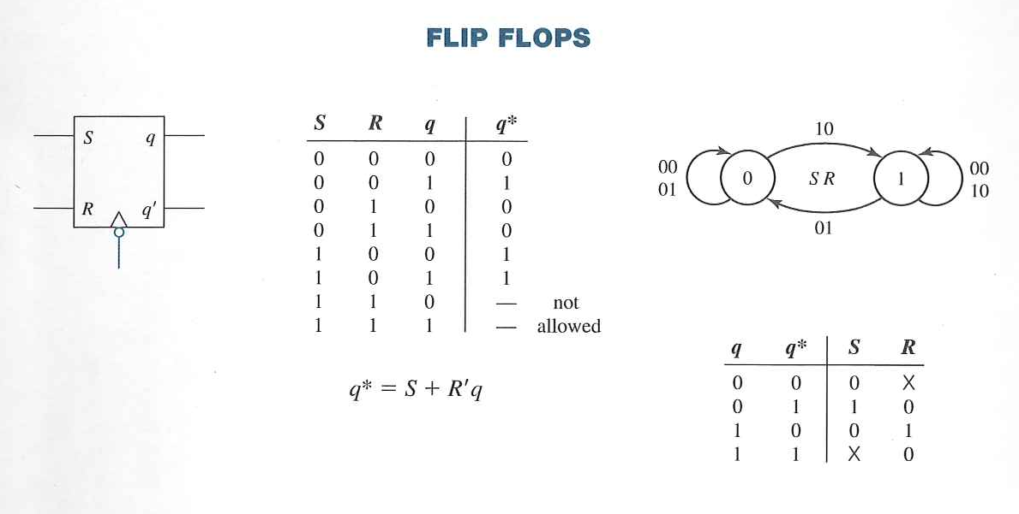

**SR Flip Flop**

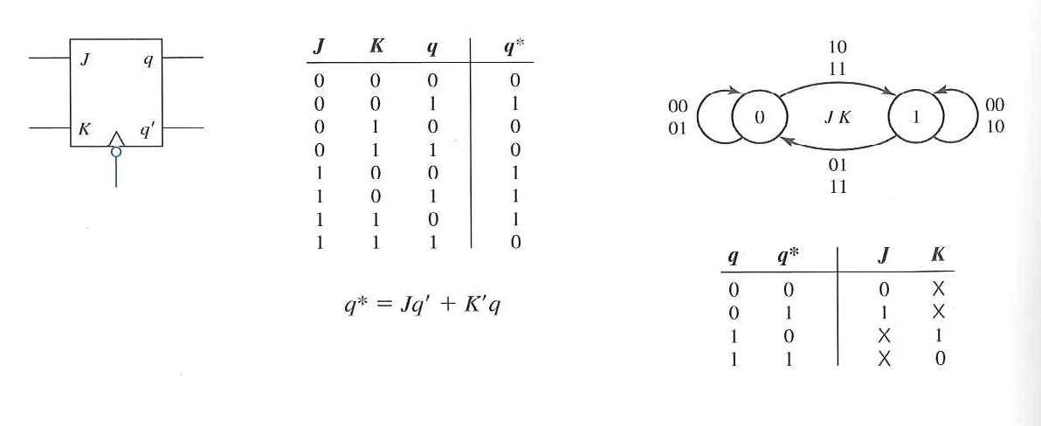

**JK Flip Flop**

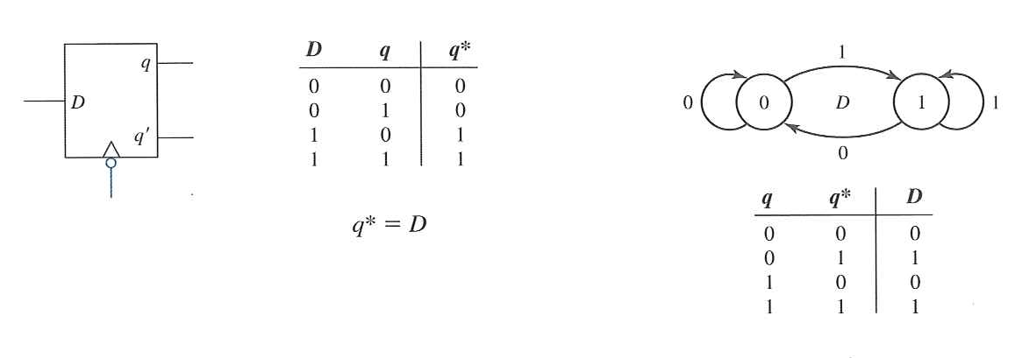

**D Flip Flop**

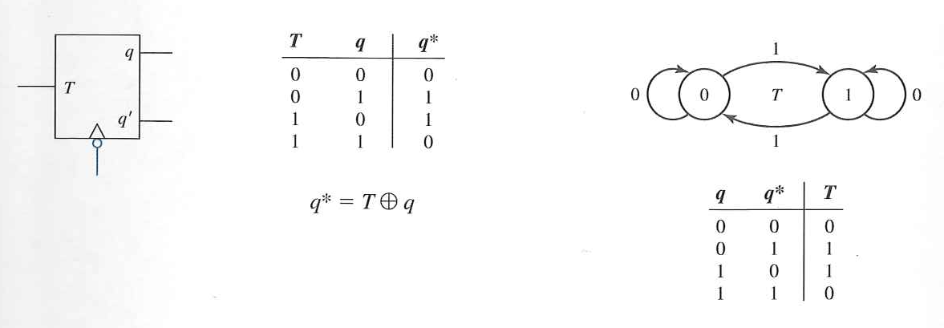**T Flip Flop**